|  |  |  |
| --- | --- | --- |
|  | **GUJARAT TECHNOLOGICAL UNIVERSITY**  Chandkheda, Ahmedabad  Affiliated |  |

Sardar Vallabhbhai Patel Institute of Technology

Vasad-041

A Report On-

**Internet of Things**

Under the course of

**DESIGN ENGINEERING – 2A (2150001)**

B. E. III, Semester – V

**(Information and Technology)**

***Submitted by:***

Team ID: 21897

|  |  |  |  |
| --- | --- | --- | --- |
| **Sr.** | **Name of student** | | **Enrolment No.** |
|  |  | |  |
| 1 | Kaustubh Wade | | 160410116050 |
| 2 | Naisargi Kothari | | 160410116051 |
| 3 | Parjita Munshi | | 160410116064 |
|  |  |
|  |  |

|  |  |
| --- | --- |
| **Prof. Amit Kariyani**  **(Faculty Guide)** | **Prof. N.V. Shah**  **(Head of Department)** |

**Academic year**

**(2018-2019)**

|  |  |  |
| --- | --- | --- |
|  | **GUJARAT TECHNOLOGICAL UNIVERSITY**  Chandkheda, Ahmedabad  Affiliated |  |

**CERTIFICATE**

This is to certify that the students namely, **Kaustubh Wade (160410116050), Naisargi Kothari (160410116051), Parjita Munshi (160410116064)** of ***B. E. (Information Technology) Semester V*** have successfully completed the course work and related tasks for the course of **Design Engineering 2A(2150001)** during the academic term ending in the month of October 2018.

Date: 08-10-2018

Place: SVIT VASAD

**Prof. Mr. Amit Kariyani Prof. Mrs. N. V. Shah**

Head of the Department

**(Faculty in charge) (Internal Examiner) (External Examiner)**

**ACKNOWLEDGEMENT**

We have taken efforts in this project. However, it would not have been possible without the kind support and help of many individuals. We would like to extend our sincere thanks to all of them.

We would like to express our gratitude towards our member of IT Department for their kind co-operation and encouragement which help us in completion of this project.

Our thanks and appreciations also go to our colleague in developing the project and people who have willingly helped us out with their abilities.

We are grateful to Mr. Amit Kariyani, our faculty member for Design Engineering, Sardar Vallabhbhai Patel Institute of Technology, under whose aegis we were provided guidance to complete the project of Design Engineering. We are highly indebted to Amit Kariyani for their guidance and constant supervision as well as for providing necessary information regarding the project & also for their support in completing the project.

Table of Contents

1. Introduction 3

2. Canvases 4

2.1. A.E.I.O.U. Canvas 4

2.1.1. A-Activity 4

2.1.2. E-Environment 4

2.1.3. I-Interaction 4

2.1.4. O-Objects 5

2.1.5. U-Users 5

2.2. Mind Mapping Canvas 7

2.3. Empathy Mapping Canvas 8

2.3.1. Users 8

2.3.2. Stakeholders 8

2.3.3. Activity 8

2.4. Ideation Canvas 10

2.4.1. People 10

2.4.2. Activities 10

2.4.3. Situation/Context/Location 10

2.4.4. Props/Possible Solution 11

2.5. Product Development Canvas 12

2.5.1. Purpose 12

2.5.2. People 12

2.5.3. Product Function 12

2.5.4. Product features 12

2.5.5. Components 12

3. Learnings Need Matrix 14

4. Rough Prototype Model 16

5. Software Requirements Specification (SRS) 17

6. Design Diagrams: 19

6.1. Class Diagram: 19

6.2. ER – Diagram: 20

6.3. Data Flow Diagram: 21

6.4. Use Case Diagram: 22

6.4.1 Use Case for Admin 22

6.4.2 Use Case for User 23

6.5. Sequence Diagram: 24

6.6. Activity Diagram: 25

7. Conclusion 26

# Introduction

Imagine a world in which every device in the home, workplace and car are connected. A world where the lights automatically turn on when the car approaches the driveway, the [coffee starts brewing](http://www.technologyguide.com/feature/coffee-tech/) when the morning alarm goes off and the front door automatically unlocks when approached by a member of the household, but stays locked when a stranger arrives on the front step. That is the type of world the Internet of Things can create.

# Canvases

## A.E.I.O.U. Canvas

There are five topics that comes under AEIOU canvas.

### A-Activity

* Communication
* Report
* Overview
* Enjoyment
* Case study
* Photography
* Lunch

### E-Environment

* Smart Home
* Wearables
* Connected Cars
* Industries
* Smart City
* Agriculture
* Entertainment System

### I-Interaction

* Admin
* Manager
* Employee
* Components
* Fan
* Air-conditioner

### O-Objects

* Controlling Device
* Electrical Appliances
* Internet
* Wi-Fi Connection
* Sensors
* Cloud Storage
* Server
* Bluetooth

### U-Users

* Engineers
* Senior Citizens
* Officers
* Doctors
* Businessmen
* Employers
* Students
* Teachers

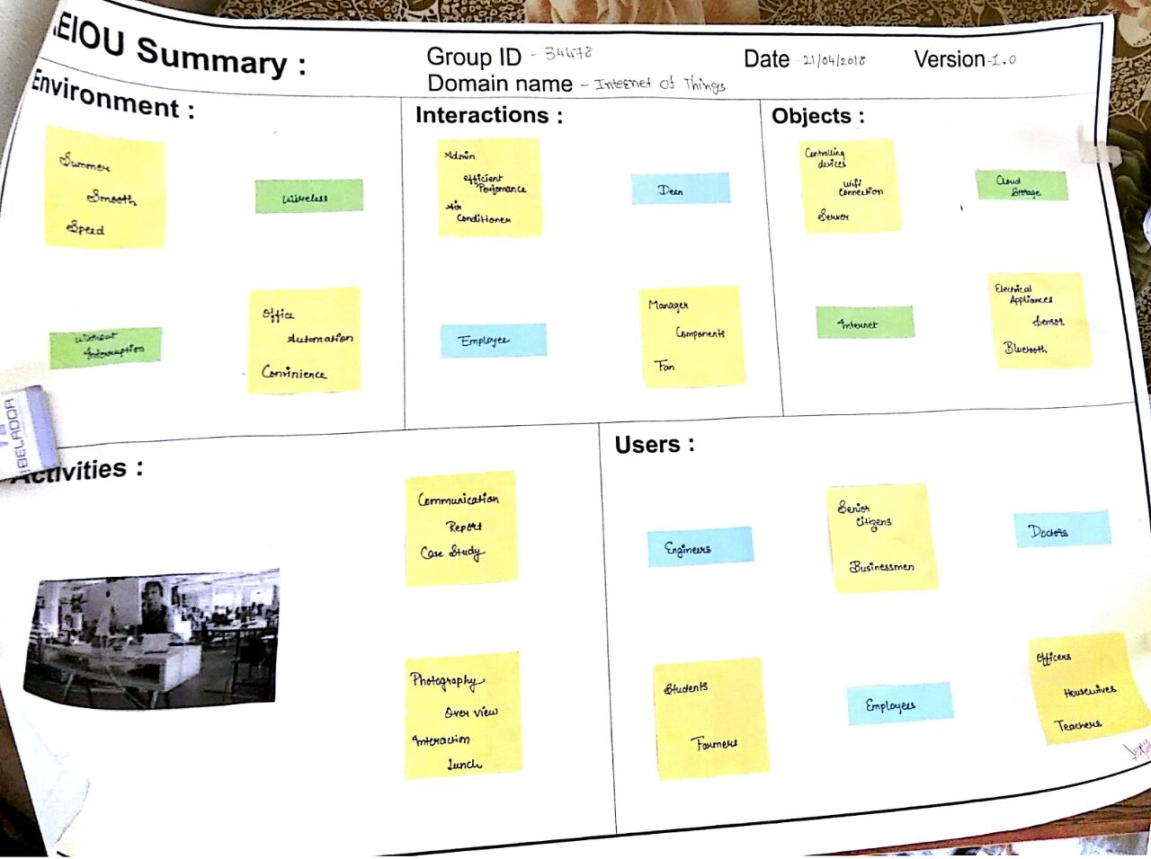

Figure 1AEIOU Canvas

## Mind Mapping Canvas

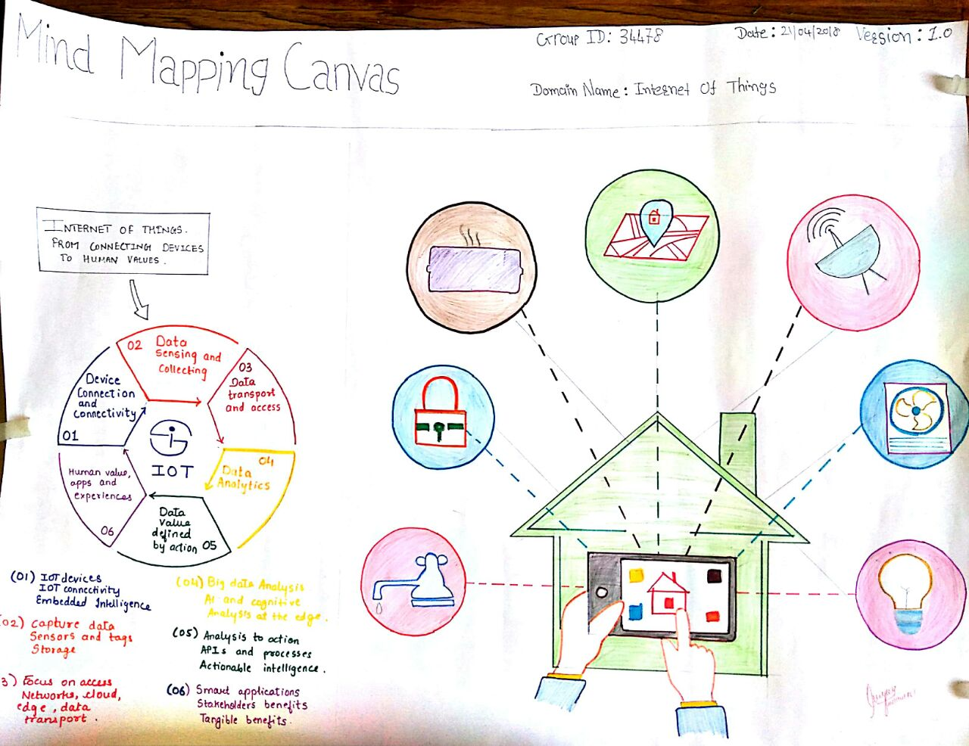

Figure 2 Mind Mapping Canvas

There are 5 features in the Mind Mapping Canvas.

* Users
* Activity
* Function
* Features
* Components

## Empathy Mapping Canvas

Here we are going to explain Users, Stack Holders and Activity. And hear story boarding which have one happy story and one sad story.

### Users

* Students
* House Wives
* Doctors
* Senior Citizens
* Teachers

### Stakeholders

* Manufacturers
* Engineers
* Servants
* Businessmen
* Dealers

### Activity

* Easy Availability for Applications
* Home Security
* Multi-Tasking
* Data Capture
* Automation
* Controlling Appliances
* Saving Electricity

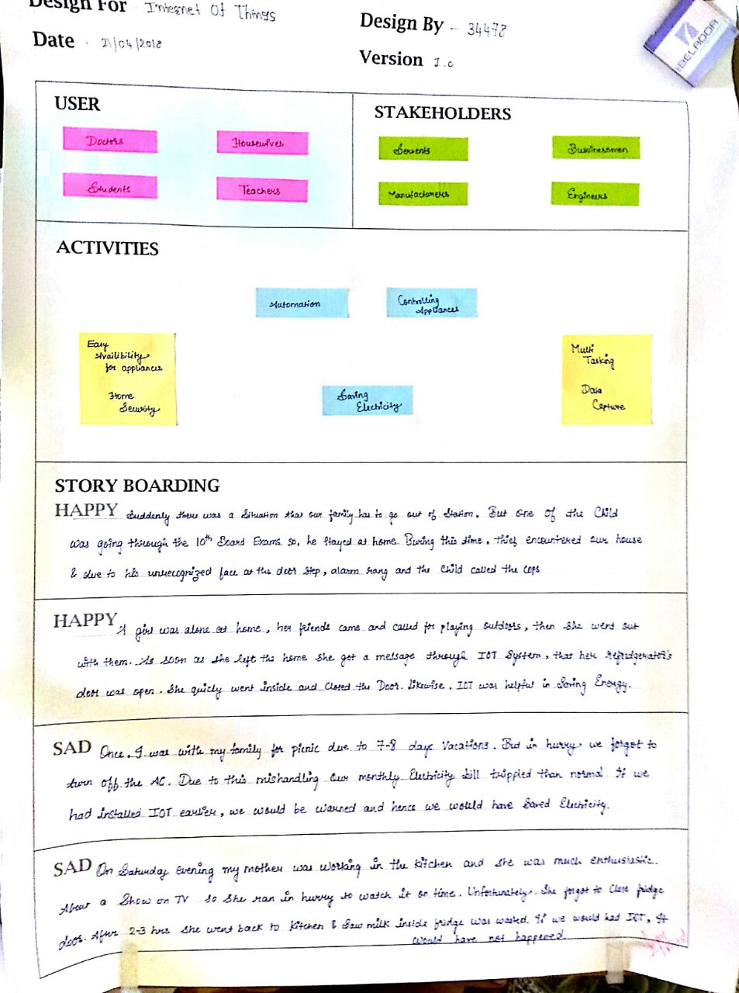

Figure 3 Empathy Mapping Canvas

## Ideation Canvas

We have described activities of people, situation and location and the problems which they face. This canvas is very helpful to reach near goal as it helped us to know the areas on which we need to focus.

### People

* Senior Citizens
* House Wives
* Businessmen
* Engineers
* Students
* Teachers
* Doctors

### Activities

* Local Sensing
* Data Capture
* Home Security
* Automation
* Home Security
* Controlling Devices
* Saving Electricity
* Multi-Tasking

### Situation/Context/Location

* Home Invasion
* Safety
* Car Parking
* Smart Metering
* Smart Farming
* Gardening
* Industry
* Living room
* College

### Props/Possible Solution

* Controlling Devices
* Sensor
* Internet Connection
* Wi-Fi
* Electrical Appliances
* Cloud Storage
* Server
* Connectors
* Bluetooth

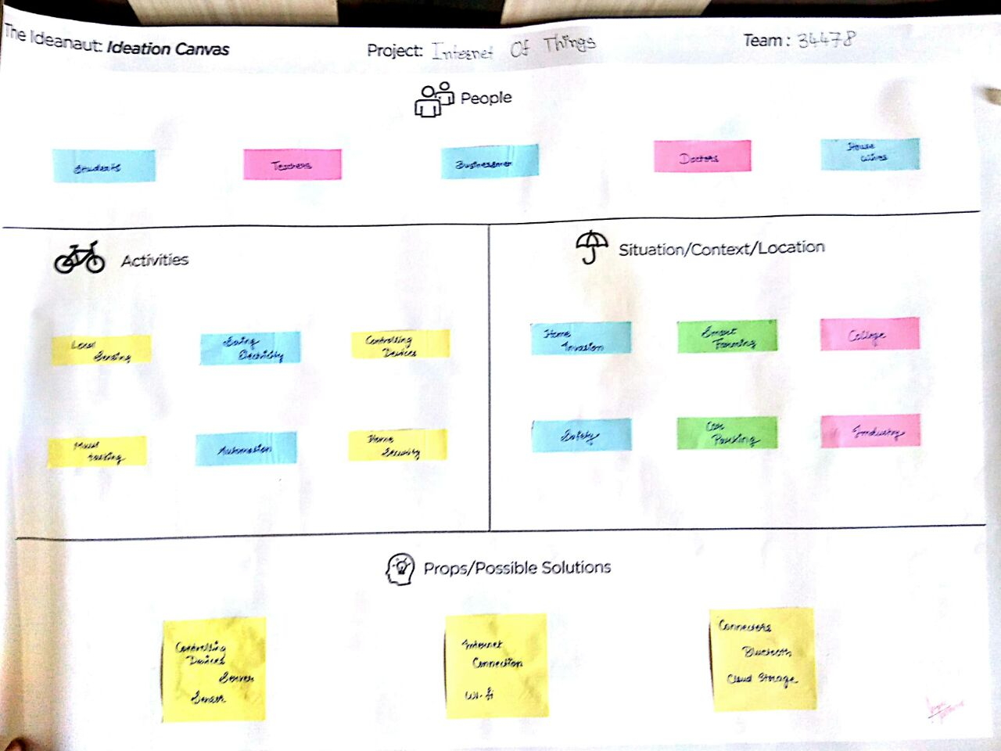

Figure 4 Ideation Canvas

## Product Development Canvas

This Canvas is helpful to understand the purpose, product experience and function of our project.

### Purpose

* Easy Handling
* Automation
* Smart Metering
* Energy Saving

### People

* House Wives
* Senior Citizens
* Students
* Engineers
* Doctors

### Product Function

* Manages range of devices
* Environmental monitoring
* Stores personal data
* Home automation

### Product features

* Saves Resources
* Security
* Command & Control
* Increases Task Efficiency
* Drives down Costs

### Components

* Controlling Devices
* Sensors
* Server
* Internet
* Wi-Fi Connection
* Connectors
* GPS, Bluetooth
* Cloud Storage
* Electrical Appliances

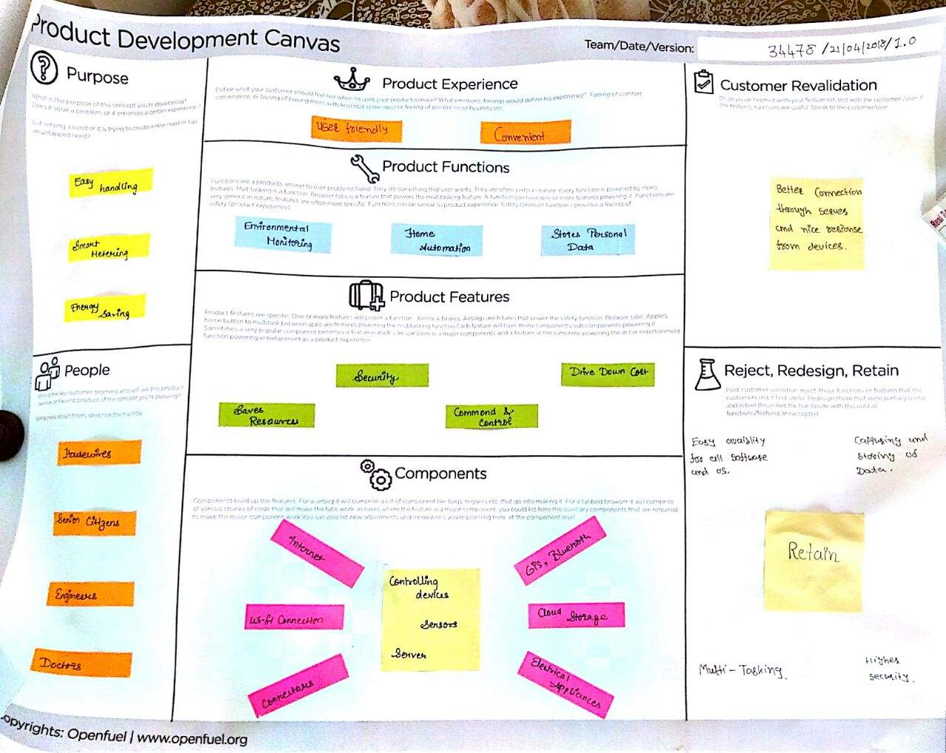

Figure 5 Product Development Canvas

# Learnings Need Matrix

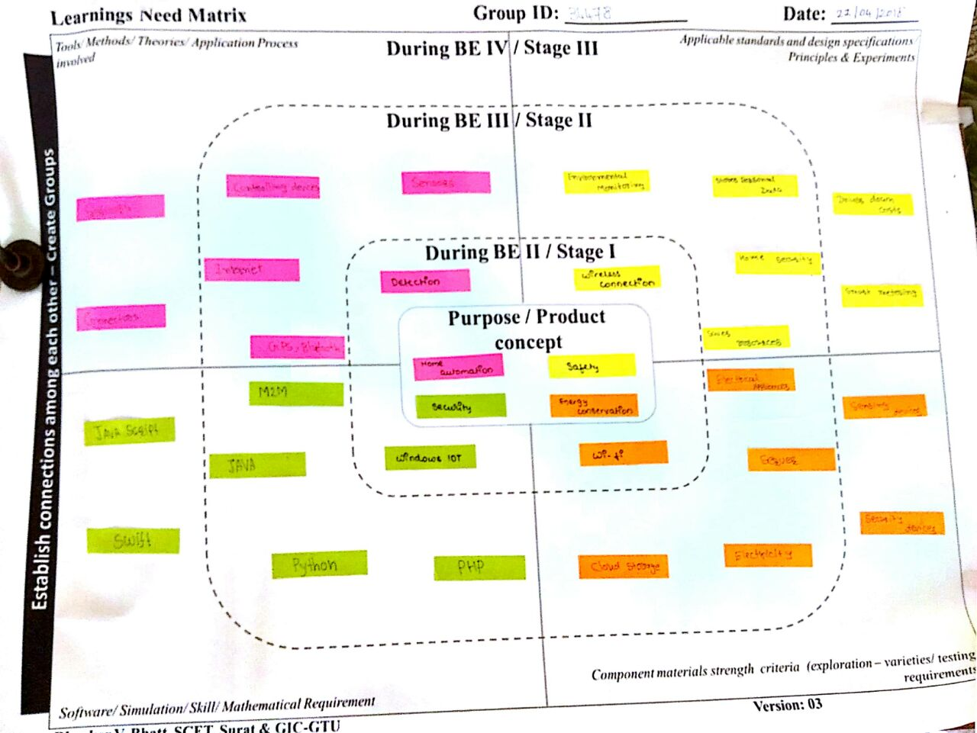

Figure 6 Learnings Need Matrix Canvas

We students, with the guidance of our Faculty Guide, need to identify at this stage, the needs for the generic learning, required while we develop their idea. The learning requirements will depend upon and may be specific for the concept/idea for our solution. This will help us to do the research in a timely manner so that we are able to obtain the specific learning/ understanding, we would require for designing the product. With understanding of the basic branch/ project related subjects, (after having discussions with and the guidance of our Faculty Guide) we will be able to identify tools/ use of software/ applicable standards/ material / design specifications/ theories/ principles/ methods/ experiments related needs to be acquired by us to complete our project successfully. After identifying the specific learning that will be required to develop our idea/product/concept further, we have to distribute learning requirements among the members of the group and each member has to learn minimum one component of LNM, in consultation with the Faculty Guide. We need to make LNM and include it in our report. LNM would include four major aspects as below:

1. Theories/ Methods/ Application Process Involved/ Mathematical Requirement
2. Applicable Standards and Design Specifications/ Principles & Experiments
3. Software/ Tools/ Simulation Methods/ Skill
4. Components Materials’ & strengths criteria (Exploration- varieties/testing requirements)

# Rough Prototype Model

# C:\Users\User\Desktop\IT Study Material\SY 1 4S\Design\IoT\WhatsApp Image 2018-04-23 at 12.45.15 PM.jpeg

Figure 7 Prototype

# Software Requirements Specification (SRS)

**Functional Requirements**

**R1.1: Provide comprehensive application detail**.

R1.1.1: The application displays detailed information of the security instructions.

Input: Select room details as per requirement and tariff.

Output: Description about the security services, alerts that the application provide as services, etc.

R1.1.2: The application provides room details which ensure the user to get constant information about the status of the room.

Input: Select the room that needs to be monitored.

Output: Description about the status of room and any activity (if any is going on).

**R1.2: Maintain user profile.**

R1.2.1: It allows the user to register.

Input: Sign up for if not registered for new user.

Output: Display form to fill up information.

Process: User fill up form and press Submit button.

R1.2.2: Application allows user to Login and update their profile if already signed up.

Input: Enter User-name and password.

Output: User gets Login, welcome message and profile will be displayed if the username and password are correct.

Process: Check user-name and password and authenticate the user.

**R1.3: Provide user support.**

R1.3.1: Provides different types of services.

Input: User selects service.

Output: Respective details of selected service and terms of service.

R1.3.2: Option available to write inquiry.

Input: Fill up inquiry form and submit it.

Output: Give one unique ID.

Process: Receive inquiries and solve problems of security related issues of the user.

**R1.4: Online status availability.**

R1.4.1: Display mode for status display for the user and alert settings that are set as per the requirement of the user.

Input: Select option to edit the settings as per the requirement.

Output: The user requested alert as per the settings set by the user.

Process: In case of any security related issues, the user will get the notification on her/his device through this security set up using the internet of things as per the settings requested by the user.

**R1.5: Feedback and reviews.**

R1.5.1: Allow the user to enter online feedback and ratings and any suggestions for the improvement.

Input: Add feedback or ratings.

Output: User forum will be displayed, and you can also write your reviews or give ratings and any suggestions for improvements.

# 6. Design Diagrams:

## 6.1. Class Diagram:

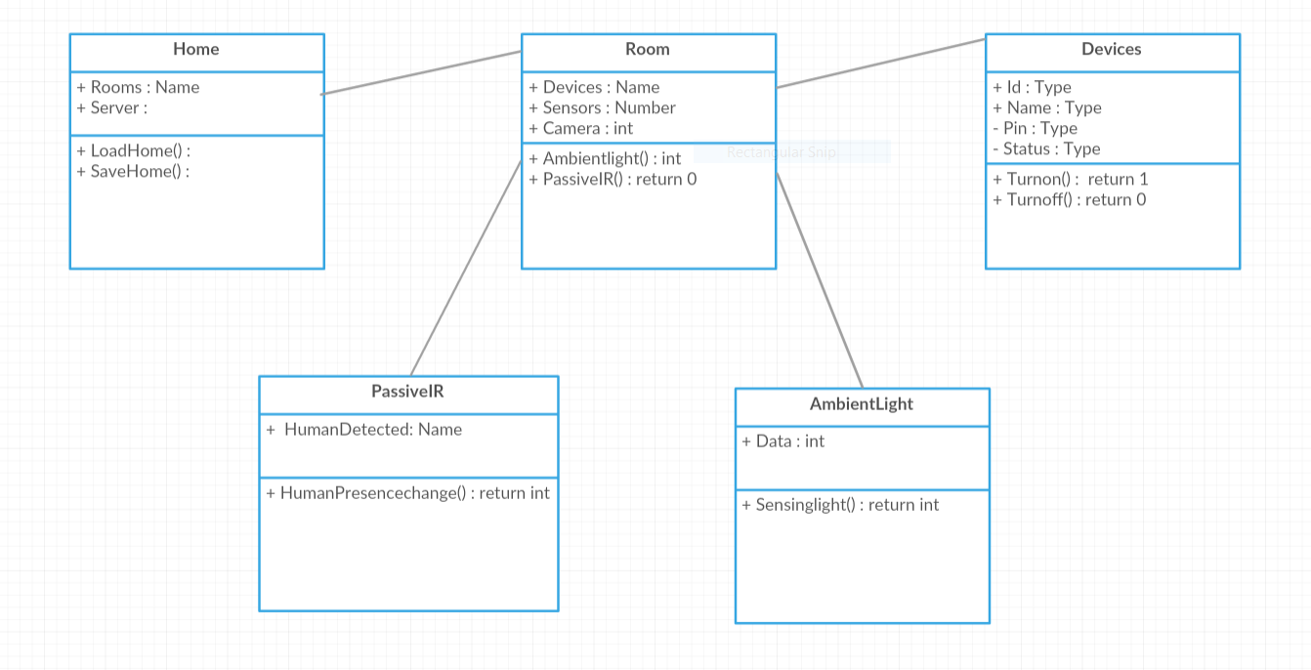

## 6.2. ER – Diagram:

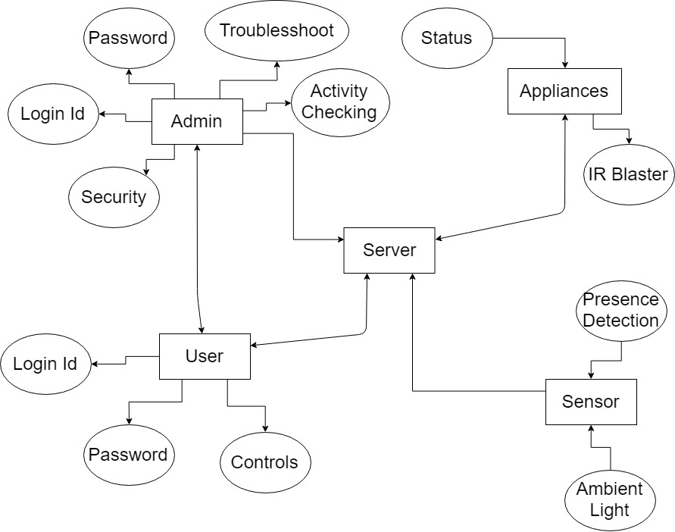

## 6.3. Data Flow Diagram:

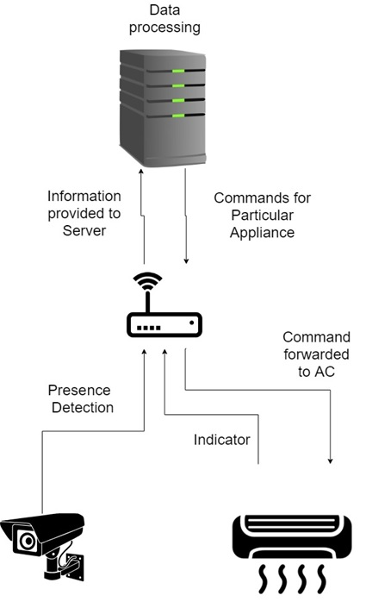

## 6.4. Use Case Diagram:

### 6.4.1 Use Case for Admin

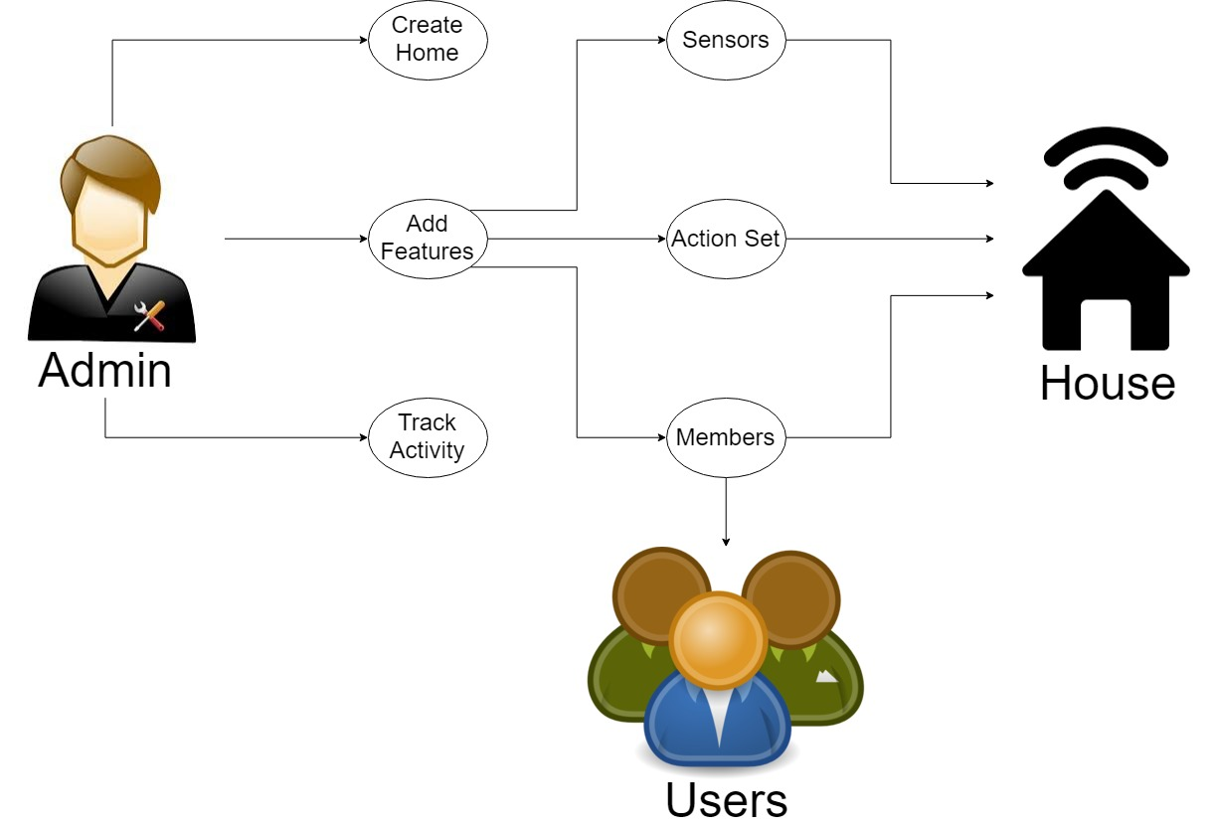

### 6.4.2 Use Case for User

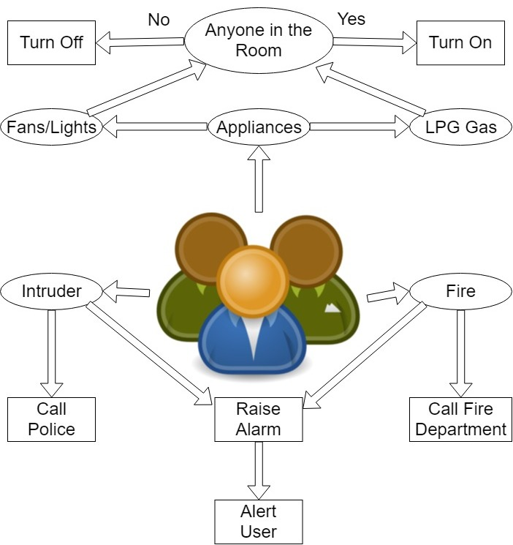

## 6.5. Sequence Diagram:

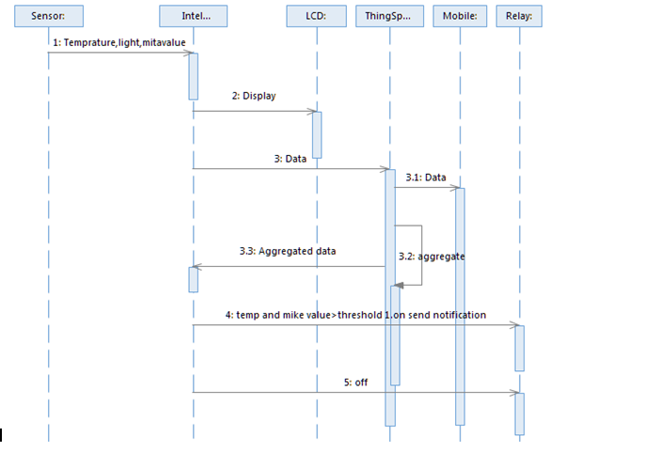

## 6.6. Activity Diagram:

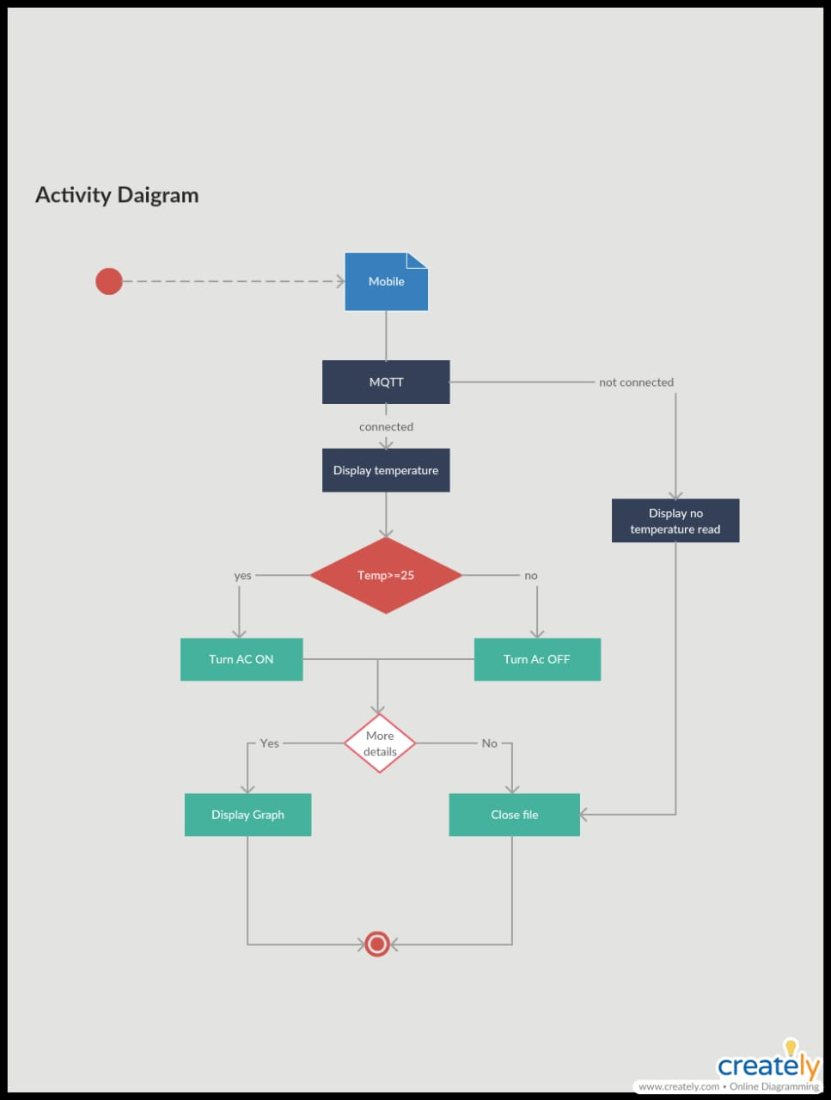

# Conclusion

In conclusion, the Internet of Things is closer to being implemented than the average person would think. Most of the necessary technology advances needed for it have already been made, and some manufacturer and agencies have already begun implementing a small-scale version of it. The main reasons why it has not truly been implemented is the impact it will have on the legal, ethical, security and social fields. Workers could potentially abuse it, hackers could potentially access it, corporations may not want to share their data, and individual people may not like the complete absence of privacy. For these reasons, the Internet of Things may very well be pushed back longer then it truly needs to be.